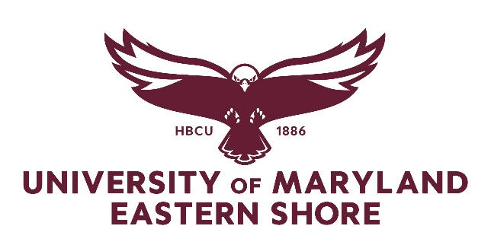

UMES Senate Minutes
April 16, 2024
Frederick Douglas Library Auditorium

- Welcome and Call to Order
- Meeting started at 11:03 am
- Meeting was called to order by Dr. Leesa Thomas-Banks
- 16 people in-person; 45 people online

- Approval of February 20, 2024 Minutes – Motion to approve minutes
- Dr. Ayodele Alade moved to approve minutes; seconded by Dr. Hwei Wang
- No Discussion. All in favor of approving minutes – None Opposed, No abstention

- Today’s Business

- Updates from The Office of Administration and Finance (VP Anastasia Rodriguez)
  - Microsoft & Outlook Conversion. Conversion this summer from Google to Microsoft and Outlook. Faculty will be able to retain their email. Google Drive will move to Microsoft OneDrive; Google Meet will move to Teams.
Google is not FERPA compliant.
Duplication of cost – change reduces cost and helps with security.
  - Pool Update. Had to address some minor issues and pool is currently being inspected. Lifeguards have been hired.
  - Parking. New parking system is in effect based on license plate (scans license plates). Guest parking – completed online – cost $1.00 a day to park. Parking will renew in time for the fall semester.

- Updates from the Office of the Provost (Dr. Grace Namwamba)
  - Middle States Self-Study. Self-study process is ongoing. Have made some good progress on report. On Monday April 22nd, the draft of the report will be released for input (for internal use only).
Key Milestones:
- August 2024 – Final draft of report will be sent to team chair
- October 2024 – Revise report
- November 2024 – Submit final report
When you receive the link of the report, please provide feedback.
- Enrollment Updates (VP Latoya Jenkins). For the spring semester, we were able to enroll 9 out of 10 students that came in the fall. There are currently over 2600 students on campus. We are ready to graduate 280 students in spring.
CAAS will lead us into New Student Orientation this July.
Friday April 26th – SpringFest - there will be several events for SpringFest week starting on Sunday.

- Updates from Senate Standing Committees
- Library Week (Dr. Carla Sewer). Library Week was April 8th -12th – had different activities at the library (several tours and a creative writing contest). We had four winners for the Creative Writing Contest – winners won iPads as awards. Looking for feedback, comments, and future ideas and suggestions.
- Senate Committees (Dr. Leesa Thomas-Banks). There are several standing Senate committees that you can sign up for if interested:
  - Academic Affairs
  - Admissions
  - Campus Security
  - Physical Plant
  - Faculty Grievance
  - Athletics
  - Library
  - Student Concerns
  - Information Technology

- Presentation: Employee Assistance Program (Ms. Gertrude Hairston)
- The Employment Assistance Program is through Guidance Resource. It is a free program, confidential, and available 24/7; accessible online, by phone, and mobile app.
- Ms. Hairston discussed the following during her presentation:
  - Confidential Emotional Support
  - Work-Life Solutions
  - Legal Guidance (Legal Representation – cost associated)
  - Financial Resources
  - Online Support

- Mental Health Awareness Month (Dr. Malkia Johnson)
  - April 24th Denim Day – The BRAVE Project – working to end gender-based violence at UMES. Asking everyone to wear Demin that day. Activities in the SSC Rotunda from 11 am – 2 pm.
  - School of Pharmacy & Health Professions – launch of UMES mobile App; only offered on Apple platforms. On Thursday April 18th – International Motivational Speaker Matt Runnalls will speak on his lived experiences with bipolar disorder, 11 am in SPHP 1126; raffling off two iPads at that time.
  - UMES Goes Green April 29th – May 3rd – Going Green will host a series of activities on Tuesday April 30th. Student can come in and do mental health screening. On Thursday May 2nd, asking the campus community to wear green on that day to show support of Mental Health Awareness - 11 am – 2 pm SSC Rotunda – Destress activities: learn reflexology, aromatherapy, create your Zen container, canvas painting, resources, and more.

- 2024 - 2025 Senate Elections (Dr. Leesa Thomas-Banks)
      - Nominations for the 2024 – 2025 senate elections are to occur at the 2nd to last meeting (this meeting). A link will be sent out for 24 hours. Will take nominations live now and through the online link.
        - Question – What positions are available?
        - Answer – All positions are available – Chair, Vice Chair, Secretary, Parliamentarian
        - Question – Is there a Treasurer position available?
        - Answer – No
        - Nomination for Chair – Dr. Malkia Johnson
        - Nomination for Vice Chair – Dr. Carla Sewer
        - Nomination for Parliamentarian – Chad Lance
        - VP Jenkins would like a lot of the great leaders that have served this past year to nominate themselves.
        - Dr. Thomas-Banks mentioned that Chair and Vice Chair cannot serve again but they can serve in other positions.
        - Nomination for Vice Chair – Dr. Leesa Thomas-Banks
        - Email will come from Dr. Thomas-Banks about nominations

- Announcements – All Members of Senate
- Health Hawk Walk – April 27th, free food & giveaways

- Adjournment
- Motion to Adjourn by Dr. Grace Namwamba, seconded by Chad Lance
- Meeting Adjourned around 11:40 am

