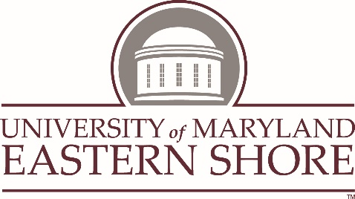
REQUEST FOR MEDICAL EXEMPTION FROM COVID-19 VACCINATION
If you have an allergy to the COVID-19 vaccine or a specific medical condition that precludes the COVID-19 vaccination requirement and you seek a medical exemption from UMES’s COVID-19 vaccination requirement, please consult with your physician and provide the following information.
Please print the following information:
Name: ___________________________________________ Date of Birth: _____________________________
E-mail: __________________________________________ Phone No.: _______________________________
Supervisor (employees): ___________________________ Department/School: ________________________
Physician Name: __________________________________ Physician Phone No.: ______________________

Physician Address: __________________________________________________________________________

Dear Physician:

The University of Maryland Eastern Shore, as mandated by the University System of Maryland, requires COVID-19 vaccinations for all students, faculty and staff. A medical exemption from COVID-19 vaccination is allowed for certain recognized contraindications (https://www.cdc.gov/vaccines/covid-19/info-by-product/clinical-considerations.html).
Please complete the form below. Should you have any questions, please contact humanresources@umes.edu or call (410) 651-6400. Thank you.

The above person should not be immunized for COVID-19 for the following reasons (Please check all that apply):
Severe allergic reaction (e.g., anaphylaxis) after a previous dose or to a component of the COVID-19 vaccine
Immediate allergic reaction of any severity to a previous dose or known (diagnosed) allergy to a component of the vaccine (Vaccine Ingredients: https://www.cdc.gov/vaccines/covid-19/info-by-product/clinical-considerations.html#Appendix-C)
Which ingredient caused an allergic reaction? ____________________________________
What was the reaction? _______________________________________________________
Which brand of the COVID-19 vaccine is contraindicated and why? ______________________
_______________________________________________________________________________
________________________________________________________________________________
How long will the medical contraindication last? _______________________________________
Other Medical Reason – Please provide this information in a separate narrative that describes the other medical reason justifying an exemption in detail.

FOR THE PHYSICIAN
I certify that _________________________________ has the above contraindication or specific medical condition and request a medical exemption from COVID-19 vaccination.

Physician Signature: ________________________________________ Date: ___________________
(Note: Signature Stamp Not Acceptable)
Physician Medical License No.: ____________________________ NPI No.: ____________________

FOR THE REQUESTOR (Student/Faculty/Staff)
Verification and Accuracy:

I verify that the above information is complete and accurate to the best of my knowledge, and I understand that any intentional misrepresentation contained in this request may result in disciplinary action which may include termination/dismissal (faculty/staff) and suspension/expulsion (students). I also understand that my request for an exemption may not be granted if it creates an undue hardship for the University.

Signature: _______________________________________________ Date: _____________________
Print Name: ______________________________________________
Hawk ID No. (students only):_______________________________________________
Signature of Parent or Guardian (if <18 years old) ________________________________________
Print Name: _______________________________________________ Date: ____________________
Confidentiality of Information Provided
Requests for exemptions and any documents provided will be kept confidential and shared only with those university employees who have a need to know.
PLEASE E-MAIL this completed form to: humanresources@umes.edu

Summary of Next Steps:
- Receipt of this medical exemption request will be acknowledged by the University Health Center (students) and/or the Office of Human Resources (faculty and staff).
- You will be notified of the decision regarding your requested medical exemption.
- If you are granted a medical exemption, you will be required to undergo COVID-19 testing in addition to observing all COVID-19 health and safety protocols.
- The University will reconsider a denial only if you bring forth new information supporting your request. For reconsideration of a denial, please contact the Office of Human Resources (for
faculty/staff) and the Office of Student Affairs (for students).

DESIGNATED OFFICE USE ONLY:
Medical Exemption Approved Date: ___________ Approving Staff Signature:_______________________

Name/ Title: _____________________________________

