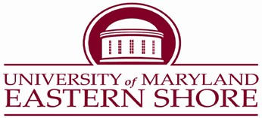

Division of Enrollment Management & Student Experience
Career & Professional Development Center
CAMPUS: (410) 651-6447 FAX: (410) 651-8048

January 31, 2023

Dear Fellow University of Maryland Eastern Shore Students:

We look forward to having you participate in our Annual Spring 2023 Career/Internship Fair that will take place on Thursday, February 16, 2023. This fair will take place in the Student Services Center Ballroom from 11:00 am – 3:00 pm.
There will be internships and employment opportunities offered. All students are welcome! Come speak to recruiters about internships, employment, and graduate/professional schools. Also, please bring your UMES ID and your resume.
Please make sure to be professionally dressed. Also, make sure to review student attachments on the Handshake Career Fair Homepage. If you need assistance with your resume or other support, contact our office at (410) 651-6447 or e-mail, Dr. Theresa Queenan, at tqueenan@umes.edu or Mrs. Bettye Hoskins-Knox at bjhoskins@umes.edu.

Disability and Smoke-Free Policy Statement

If you have a disability and require reasonable accommodations that we need to provide in order to facilitate your full participation in this program/event, please contact Mr. Jason Casares, Director; Student Disability Services (410) 651-7848. Please allow 3-5 days to arrange the accommodations. UMES is a smoke-free campus.

