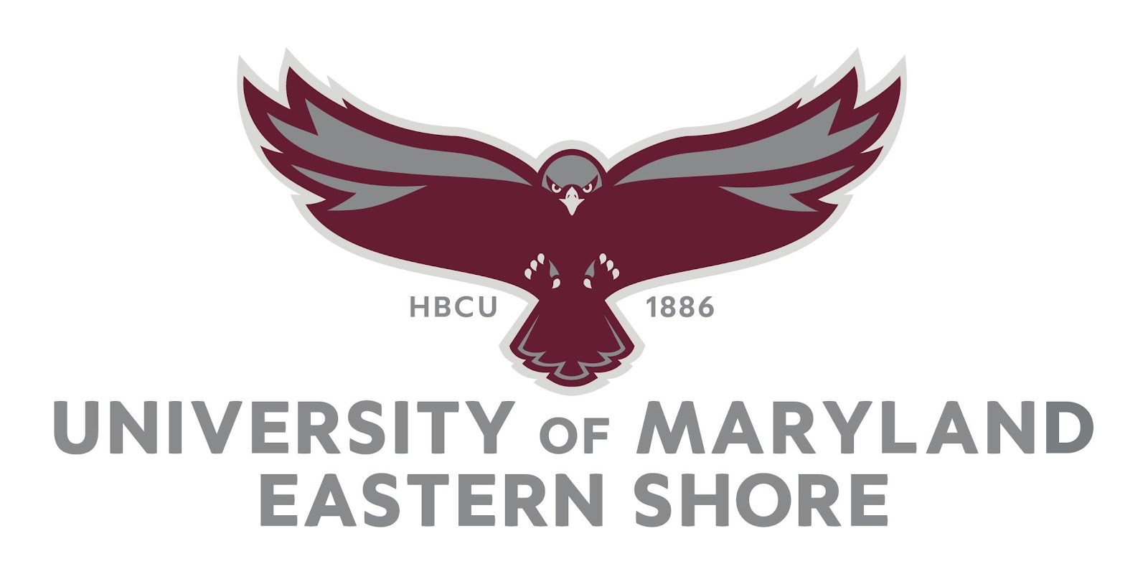

Joint Faculty and Senate Assembly Minutes

Faculty Assembly Minutes. March 14, 2023
Tiara Cornelius brought the meeting to order 11:05.
The minutes were approved.
The Agenda was approved, no one opposed. One abstention.
Moving on to today’s business:
Updates from President Anderson, and Provost Ronnie Allen. Dr. Anderson is at a meeting with the Thurgood College Fund for presidents.
Good morning. He is going to yield his time to Grace Namwamba
She is here to share some important information about the middle states accreditation.
Today is the UMES Middle States Self-Study Kickoff, towards accreditation. You can see that the hawk is soaring ready to take off for this important process.
Middle States Commission on Higher Education is our accrediting institution.
About Middle States: The University of Maryland Eastern Shore (UMES) is accredited by the Middle states Commission on Higher Education (MSCHE). MSCHE is an institutional accreditor that accredits institutions of higher education throughout the United States of America, mostly in our region. MSCHE accreditation is separate and distinct from program specific accreditation. We have to meet seven standards, which used to be fourteen, but it doesn’t mean we have to do anything less. It is now organized into seven standards. There are seven standards that a college/university must meet in order to maintain its accreditation. UMES is preparing for the reaffirmation of accreditation as part of the normal cycle. The site visit by MSCHE is planned for spring, 2025.
So The thing for our self-study is soaring above and beyond. Working together, we will soar above and beyond, and we will do really well with our self study.
In 2022, we did several things, but the major one was that we selected the members of the Steering committee and we attended the Self Study Institute.
In 2023, March 14thThe work is getting a little heavier. University kickoff. You can see that we are kicking off. September 15th Self-Study Design submission to the VP Liaison. There are several steps to get that ready. September 19, Self- study group will get a visit by the VP Liaison. December 13th. First draft of self-Study document. We will be working very hard in between.
In 2024. January –August. We will select our team Chair, Submission of final draft of Self-study document to Team Chair. This will be the person who will be conducting the site visit. By August we will have a final draft. It doesn’t get final to the very end. That person will be visiting us in in September 2024. We will get regular updates.
September- October. Team Chair preliminary visit. Sharing of final Self-Study with the campus community. We will share the report. November: Uploading of final Self Study report to MSCHE portal.
In 2025: January: Preparation of campus community for the site visit. We have already started preparing. We need to start thinking about the site visit and what we can do. The team will come sometime between January and May to verify what we have said in our self-study. Hopefully, the team won’t come in January, but will be a little later. So that is our time line.
January – May MSCHE Site visit at UMES. Our mission, and vision. She will give us the link so that we can visit and be familiar with some of these things, because they like to know how we are linking our activities between our mission and vision. And things like that. We also have our core values. These are posted on our website for you can read and be familiar with these. For the self-study we have to select a few so that we can focus on these.
The institution has many priorities.
Self-Study Institutional Priorities. The steering committee selected three.
Please provide feedback by Friday, March 17th, 2023. We cannot do anything until we have this; she is not trying to rush us. So we can get into the work of the self-study: It should be in our email:

UMES Campus Survey - Institutional Priorities for MSCHE Accreditation Self-Study

Please consider these institutional priorities agreed by the Accreditation Steering Group and indicate whether you are in agreement. You are free to suggest additions or amendments.
The priorities are organized under three themes: the first two questions are under 'Ensure student success,' the next two are under 'Improve Financial Sustainability and university processes', and the final two questions are under 'Advance Diversity, Equity, and Inclusion.' Importantly, all priorities have been mapped to the UMES Strategic Plan, and the MSCHE Standards.
Thanks for your participation in framing our university's institutional priorities.

Question Title

* 1. Ensure academic programs are future-focused and prepare graduates for successful careers.
Strongly agree
Agree
Neither agree nor disagree
Disagree
Strongly disagree

Question Title

* 2. Embed a culture of continuous improvement in all student services (academic and non-academic) to increase retention (75%) and graduation rates (55%).
Strongly agree
Agree
Neither agree nor disagree
Disagree
Strongly disagree

Question Title

* 3. Leverage our fiscal resources to enhance ROI and create a sustainable future for UMES.
Strongly agree
Agree
Neither agree nor disagree

Disagree
Strongly disagree

Question Title

* 4. Optimize processes for efficiency and improve the faculty, staff, and student experience.
Strongly agree
Agree
Neither agree nor disagree
Disagree
Strongly disagree

Question Title

* 5. Promote diversity, equity, and inclusion in our policies, practices, and endeavors.
Strongly agree
Agree
Neither agree nor disagree
Disagree
Strongly disagree

Question Title

* 6. Instill in our students an appreciation and support for fairness, open-mindedness, and service to others.
Strongly agree
Agree
Neither agree nor disagree
Disagree
Strongly disagree

Question Title

7. Please email us if you have any suggestions or amendments to the above priorities.
Yes
No suggestions

People involved: Dr. Namwamba, Dr. Gopalan, Dr. Faust, Dr. Allen, Mr. Harrington, Dr. Hollywood, Dr. Harris, Dr. Johnson, Dr. Talley, Dr. Wiggins, Ms. Latoya Jenkins, Ms. Rodriguez, alumni, board members and students will be added. Their names will be on the website that she will share with us.
Self-Study information. https://wwwcp.umes.edu/middlestates/
We ask you to visit the website and to give us feedback. Any questions? Thank you very much. Stop sharing. Close the link.
Ensure students success:
Ensure academic programs are future-focused and prepare graduates for successful careers:
Embed culture of continuous improvement in all student services (academic and non-academic) to increase retention (75%) and graduation rates (55%).
Improve Financial Sustainability and university processes:
Leverage our fiscal resources to enhance ROI and create a sustainable future for UMES.
Optimize processes for efficiency and improve the faculty, staff and student experience
Advance Diversity, Equity and Inclusion:
Promote diversity, equity and inclusion in our policies, practices and endeavors.
Instill in our students an appreciation and support for fairness, open-mindedness and service to others.

Moving right along: Standing committees for faculty assembly.
Ms. Corrie Cotton will give us updates from the faculty concerns committee.
The top ten faculty concerns have been identified, with compensation being the top concern. They are creating a short compensation survey. Be on the lookout over the next several weeks.

UMES senate by Dr. Joyce Bell and Mr. Joseph Bree.
We are working on the senate composition. We need to have an accurate voting body. We are looking at how to put together a membership list this month. The goal is to have a list for you by next month. There will be a list for voting. They are working on it. Ms. Shenita Reddick will help with this. It is a slow process but we are making progress. In order to change the composition. We have to have a current makeup, so that we have to establish the list of membership, then we can conduct the legal business, and then we can create a group of people to look at the composition and then change the constitution. It is heavy in faculty. We are looking at having the senate be more representative of the whole campus, and not so heavy in the faculty.
The next piece of business: the Senate library updates by Dr. Craven.
National Library Week. April 23-29th, 2023 Mr. Bree resuscitated this! There are six members of the library committee. We are hoping to get your support for the events.
To increase the student use of the Frederick Douglass Library and to remind the faculty about all of the tools available
The theme- “There’s more to the story”, “It is not your grandfather’s library.” Aspirational- a week of activities where something is going on, with prizes and food. Student services has generously offered to donate some prizes.
Sunday, April 23- Not so remote. Libraries are a click away.
Monday April 24. The history of Libraries
Tuesday April 25. Study library Jeopardy and it is national library workers day. Hoping for many Thank you notes to keep our research alive.
Wed- Student Escape room- No Shushing day. Hoping graduate studies will engage and will sponsor some prizes.
Launching a writing contest. There is more to the story. Offering a spot on a pod cast to read their writing aloud.
Friday, April 28th, Pharmacy building day- hoping to bring the library to the new building.
April 29th. Hawk walk from Dept. of Kinesiology. Drag story at the library, Fashion show at the library to highlight, lots of different librarians to emulate.
When in Doubt go to the Library. Committee: Joseph Bree, Cynthia Cravens, Charlene Harris, Lily Tsai, Janet Eke, Bryan Bergen-Aurand, Kelsie Endicott, Kathryn Barrett-Gaines, Marie-Therese Oyalowo, Bonita Jones,
These are all aspirational: We will have to decide which ones will stay, and please send us a list of activities.
How will students learn about this? Welcoming student representation for this! Three students have agreed to be on the committee. They are open to tweaking the events; Students will be invited to the next meeting. Looking for invitations, and sponsorships.
Innovations and Teaching and Learning conference- call for proposals until April 2017. Looking for what best works for you. Looking for how you like to engage in a virtual conference. There is an advisory group, innovative formats and different types of topics. Will give a link for proposal submission and registration.
There are some good things going on at UMES. Brave projects: In Jason’s office. Cecelia Rivera- Back in October, they filmed four videos- paying and funding violence prevention. Actors are UMES students, worked with a group in Salisbury.
Videos are two minutes or less. From the Office of Institutional Equity and compliance. One on consent, stalking, one on dating violence, one on active bystander intervention.
Reminder, April is Sexual Assault Awareness month. Any type of gender violence, we are mandated reporters and required to report.
Quick history of this council on Issues Concerning Women. “Our mission is to advocate in the interest of the group of individuals at UMES identifying as woman by celebrating women, creating an inclusive and supportive environment and conferring with the president on related issues.” There is a system wide organization already. Dr. Burdell spoke.
Kathryn Barrett Gaines was the one who initiated on UMES campus.
Current projects:
Public profiles of UMES women for the benefit of our students during women’s Herstory Month.
Mr. Errol Holland, Director in charge of public relations, is Working with Amy Hagenrater-gooding and Kathryn Barrett-Gaines and their students to create videos celebrating four women from UMES history- Lida Brown, Portia Byrd, Mary Fairberkes, Mary Irene Atlee.
Will be surveying the campus climate regarding Women’s issues at UMES with a one question survey. Anyone can join the committee. However you define yourself, you can be on this committee. Currently 25 members. No Questions.
Any new business that needs to be discussed? Think about ways we can incorporate woman into our courses, and business.
Voting for ReTool your school. Trying to get from 9th place to 6th place. The link is on the website. Enjoy the spring break. Today is national Potato chip day and Happy Pi Day.
Entertaining a motion to adjourn the meeting. Adjourned.

